Year 9 term 3 Chemistry Revision Sheet
You may need a periodic table for some of the following questions.
1. Summary (fill-in-the-blanks):
The subatomic particles in the nucleus of an atom are the _________ and ___________. The atomic number represents the number of _________ in an atoms ________. The mass number is the total number of ________ and ________ in the nucleus. Isotopes of an element are the same in the number of __________but differ in the number of ___________. (8)
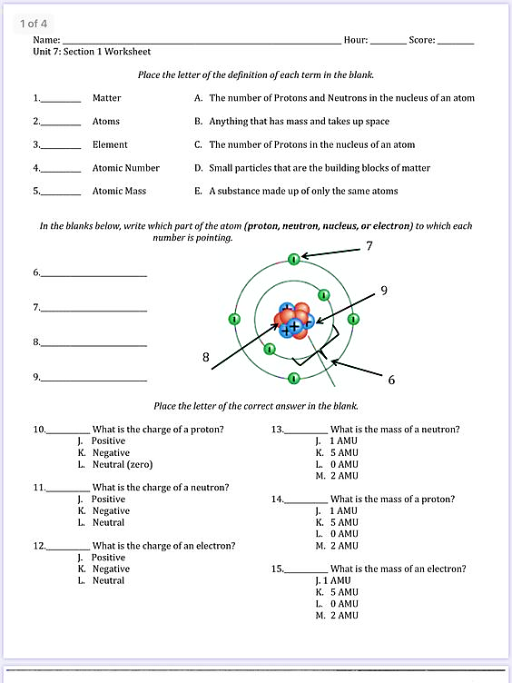
2. Write the letter of the correct definition beside each term (5)

3. In the blank spaces below write in the name of the atom part that number is pointing to in the diagram (4)

4. Use the template below to complete a diagram representing the electron arrangement (in the shells shown) for the element listed beside the diagram. (9)
__P
__N
__P
__N
__P
__N
Oxygen
Helium
Calcium

5. If an atom has the same number of protons and electrons, it’s charge is
(a) Negative (b) positive (c) neutral (d) non existant. (1)
6. Compared to the protons and neutrons the mass of an electron is
(a) massive (b) 10 000 times larger (c) the same (d) almost zero. (1)
7. Define the following terms. (3)
atomic number
mass number
isotope

8. How many protons are found in
a. ¹² C? b. ¹³ C?  9. How many neutrons are found in | c. | ¹⁴ C?
a. ¹² C? b. ¹³ C?  10. How many electrons are found in | c. | ¹⁴ C?
a. ¹² C? b. ¹³ C? | c. | ¹⁴ C?
(3)

11. Use the periodic table to complete the following table:
 | Symbol | Atomic Number | Mass Number | Number of Protons | Number of Neutrons | Number of Electrons
 | ⁴⁰K
 | ³²P
 | ⁶⁵Zn
⁸¹Br
 | ²³⁵U
(5)

12. The following statement contains an error. Rewrite the statement so that it is more correct.
An ¹⁸O atom contains the same number of protons, neutrons, and electrons as an ¹⁶O atom.

(1)

14. Describe what the ¹²C and ¹⁴C isotopes of carbon have in common and how they are different.
(2)
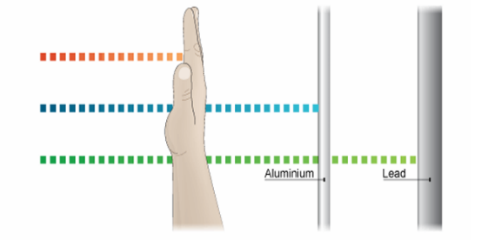
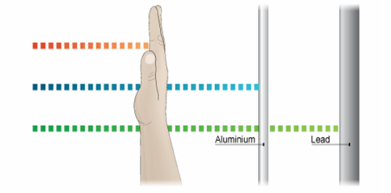
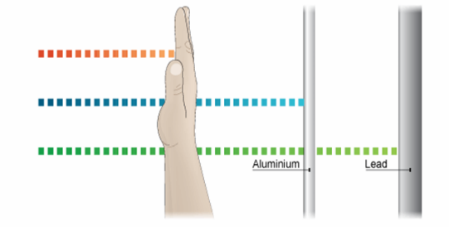
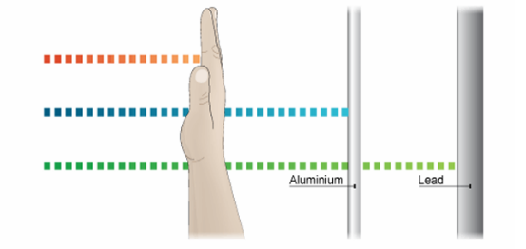
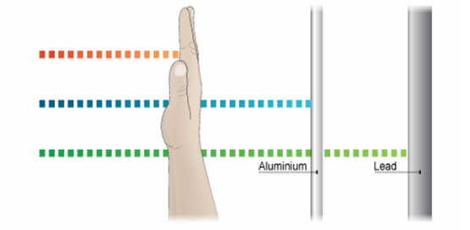
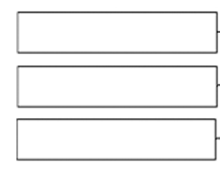
15. In the diagram below, there are three type of radioactive radiation shown. Identify each of the radiations as being alpha, Beta, or gamma radiation
Radiation type A =
Radiation type B =
Radiation type C=
(3)

16. Radon, iodine and Cobalt all have radioactive isotopes. The isotopes each undergo radioactive decay according to the nuclear equations shown below. Use the clues in the equations below to complete the missing atomic and mass numbers, and identify the type of radiation being emitted in the equation.
- ${}_{88}^{226}{Ra} → {}_{86}^{222}{Rn} +$ : the radiation emitted is _____________
- ${}_{53}^{131}I → {}_{54}^{131}{Xe} +$ : the radiation emitted is _____________
- ${}_{27}^{60}{Co} → {}_{28}^{60}{Ni} +$ + ______ rays
The radiation emitted is _____________ and ______________
(6)

17. Match the following models/discoveries/theory/law with the related person/experiment:

- Idea of the atom as indivisible
ii. Plum Pudding Model
iii. Nuclear Atom – atoms have a very small dense nucleus
iv. different elements are made from different atoms which can combine to make other matter
v. electrons in an atom exist in shells
a. Rutherford / Gold foil experiment
b. Neils Bohr / emission spectra
c. Thompson / Discovery of the electron
d. Democritus
e. John Dalton
(5)
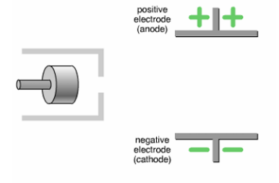
18. In the diagram on the right draw the path that alpha, Beta, and gamma radiation would take in the electric field. (3)

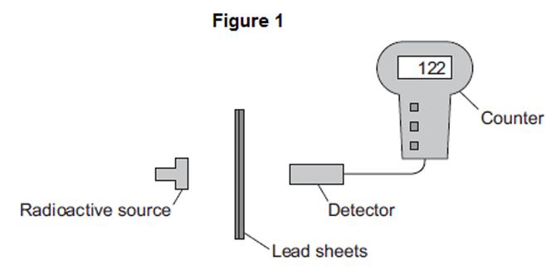
19. In an experiment, a teacher put a 2 mm thick lead sheet in front of a radioactive source. She used a detector and counter to measure the radiation passing through the lead sheet in one minute.
She then put different numbers of lead sheets, each 2 mm thick, in front of the radioactive source and measured the radiation passing through in one minute.
The apparatus the teacher used is shown in Figure 1.

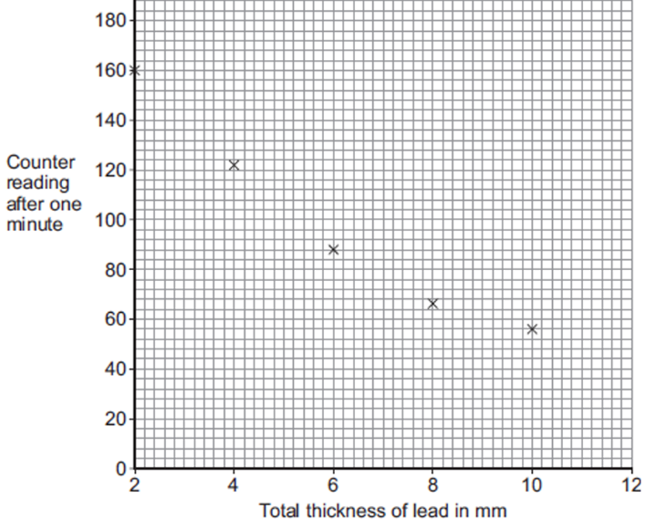
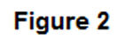
(c) The readings taken by the teacher are plotted in Figure 2.
(i) Draw a line of best fit to complete Figure 2. (1)
(ii) identify the trend shown on the graph (ie. What effect does the total thickness of lead have on the counter reading)? Use data from the graph to support your answer. (2)

(iii) Use Figure 2 to estimate the reading on the counter when the total thickness of the lead is increased to 12 mm. (1)

(iv) What type of radiation was emitted from the radioactive source? Explain your answer. (2)

(v) What was the independent variable in this experiment? (1)
(vi) What was the dependent variable? (1)
(vii) Suggest one controlled variable for this experiment. (1)

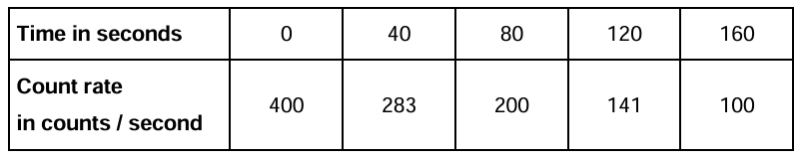
20. The table below shows how the count rate from a radioactive source changes with time.
Use the table to calculate the count rate after 240 seconds. Explain your reasoning (2)

21. The graph shows how, in a sample of air, the number of radon-222 nuclei changes with time.
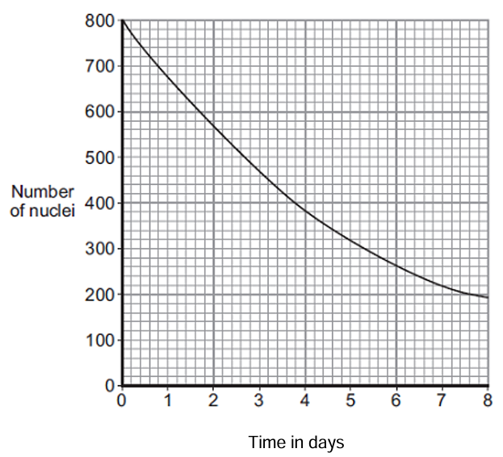
- Use the graph to find the half-life of radon-222. Show clearly on the graph how you obtain your answer.
Half-life =............... days (2)

- Estimate the amount of time that would pass for the sample to reduce to 100 nuclei. Show your calculation. (2)

22. For each of the following chemical reaction, identify the reactants and the products, and balance the reaction.
- __N₂ + __H₂ → __NH₃
Reactants: ____________ Products:_______________ (2)
- __P₂O₃ → __P₄ + __O₂
Reactants: ____________ Products:_______________ (2)
- __AgNO₃ + __Cu → __Cu(NO₃)₂ + __Ag
Reactants: ____________ Products:_______________ (2)
- __CH₄ + __O₂ → __CO₂ + __H₂O
Reactants: ____________ Products:_______________ (2)
- __MgF₂ + __Li₂CO₃ → __MgCO₃ + __LiF
Reactants: ____________ Products:_______________ (2)

23. For each of the chemical reaction described below, identify the reactants and the products, and write a balanced chemical equation.
a) Solid calcium chloride (CaCl₂) can react with water to produce hydrogen chloride gas (HCl) and calcium oxide (CaO).
Reactants: ____________ Products:_______________
Balanced equation: ________________________________________________ (3)
b) Liquid ethanol (C₂H₅OH) will burn in oxygen gas (O₂) to produce water and carbon dioxide gas (CO₂).
Reactants: ____________ Products:_______________
Balanced equation: ________________________________________________ (3)
c) Lithium carbonate (LiCO₃) reacts with hydrochloric acid (HCl) to produce water, carbon dioxide gas (CO₂), and lithium chloride (LiCl).
Reactants: ____________ Products:_______________
Balanced equation: ________________________________________________ (3)

24. State the law of conservation of matter (Mass) and explain what it means in terms of the reaction shown below.
Law of conservation of matter:
(1)
Reaction: Si + O₂ → Si₂O₆
(1)

